
Data Stuctures
Submitted by: 241484_Huzaifa Basit
To: Ma’m Mehmoona Jabeen
Cyber Security Fall 2024-B

Project Title:

Emergency Route Finder for Ambulances Using Graph Algorithms:
Group Mates:

Huzaifa Basit
- Kashmala Deen Keerio
- Hasnat Haider Mir
- Rafia

Introduction:
Ambulances must reach patients and hospitals as quickly as possible.
However, in real life, ambulances often get delayed due to:
Traffic congestion
Roadblocks
Accidents
Poor route selection
To solve this, navigation systems must compute the fastest possible path in real time.
This project uses graph theory and data structures to build an efficient emergency route finder.
It demonstrates the importance of DS (graphs, priority queues, adjacency lists) in solving real traffic and navigation issues.

Problem Statement:
Ambulances lose critical minutes due to traffic and poor routing decisions.
There is no simple algorithmic system that:
Models roads
Considers traffic as weights
Provides shortest (fastest) path

Avoids blocked or slow roads
As a result:
Patients may not reach hospitals in time
Emergency response becomes inefficient
Traffic congestion worsens
We need a system that can:
Represent the city roads
Find the fastest route
Adapt to dynamic conditions
Work efficiently for large road networks

Objectives:
To model a road network using graph data structures.
To find the shortest and fastest path for ambulances.
To use BFS/DFS for traversal and Dijkstra for optimal path.
To reduce emergency travel delays.
To demonstrate real-life application of DS in navigation.

Methodology:

1. Data Collection
Collect number of intersections
Collect road distances or travel times
Represent them as a weighted graph

2. Graph Modeling

Use adjacency list
Each node stores connected nodes & weight

3. Algorithm Selection
BFS → for unweighted testing
DFS → path exploration
Dijkstra → choose fastest route

4. Path Reconstruction
Store parent nodes
Backtrack to print final path

5. Output Display
Show shortest distance/time
Show path nodes in order

Algorithms Used:

⭐ 1. BFS (Breadth First Search)
Used for shortest path in unweighted graphs.
Finds shortest number of steps
Good for small emergency zones

⭐ 2. DFS (Depth First Search)
Used to explore all possible routes, not optimal for shortest path.
Good for:

Checking whether path exists
Finding alternate routes

⭐ 3. Dijkstra’s Algorithm (Main Algorithm)
Used for fastest path, considering weights (traffic or distance).

Steps:
Set distance of all nodes to infinity
Set starting node distance = 0
Use priority queue to pick the minimum weight path
Update distances of neighbors
Continue until destination is reached

Why Dijkstra?
Handles real world weighted roads
Guarantees shortest path
Efficient with priority queue (O(E log V))

Expected Output:
User selects:
Start location
Hospital location
System outputs:

Shortest Path
Fastest Route: 0 → 3 → 2 → 5

Time Taken
Total Estimated Time: 11 minutes

Alternate Route (if needed)
Alternate Route: 0 → 1 → 4 → 5

Graph view (optional)
0 --5--> 1 --4--> 4 --2--> 5

Importance Of The Project:

Saves Lives
Ambulances reach faster → higher survival rate.

Reduces Traffic Delays
Optimizes movement in dense cities.

Real-World Application
Used in Google Maps, Rescue 1122, Fire Brigade.

Uses DS Concepts
Graph
Priority Queue
Dijkstra
BFS/DFS

Can be expanded to full navigation system.

Conclusion:
This project successfully demonstrates how Data Structures (graphs, queues, priority queues) and algorithms (BFS, DFS, Dijkstra) can solve a real-world problem: reducing ambulance delays due to traffic.
The system efficiently models the road network and finds the fastest and safest path.
This proves the importance of DS in making life-saving applications and can be extended into a complete smart city navigation module.
C++ Code:
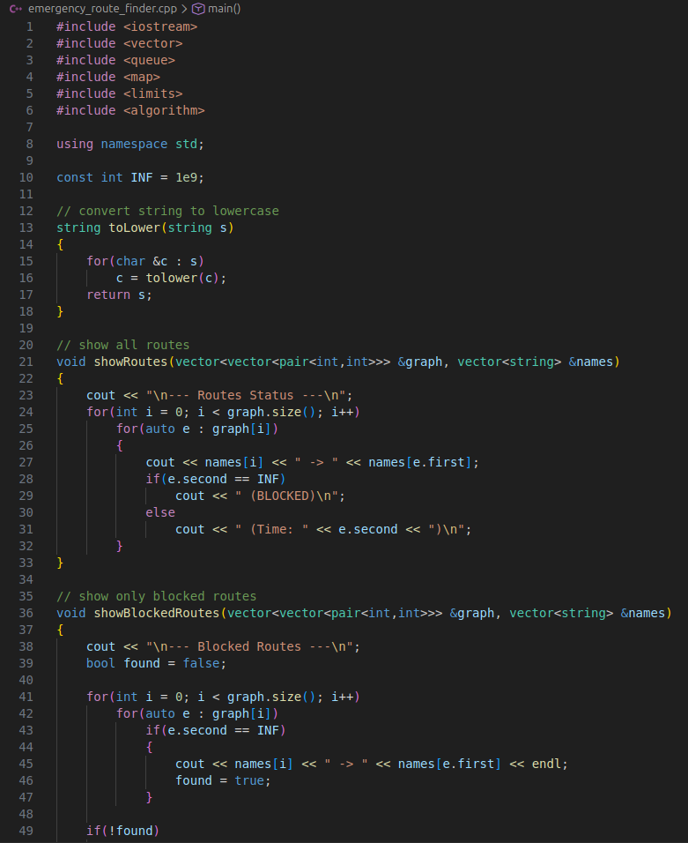
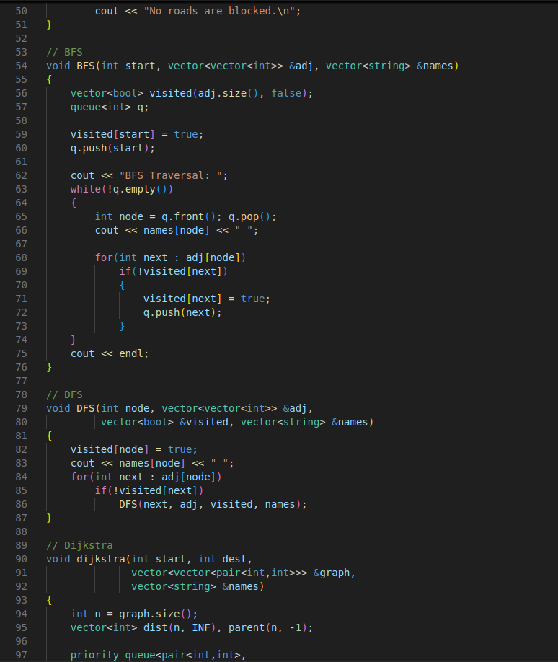
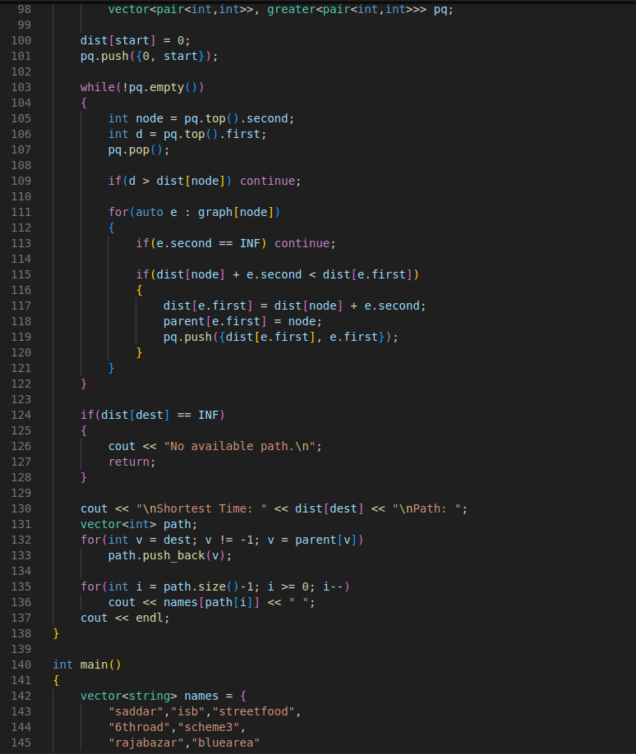
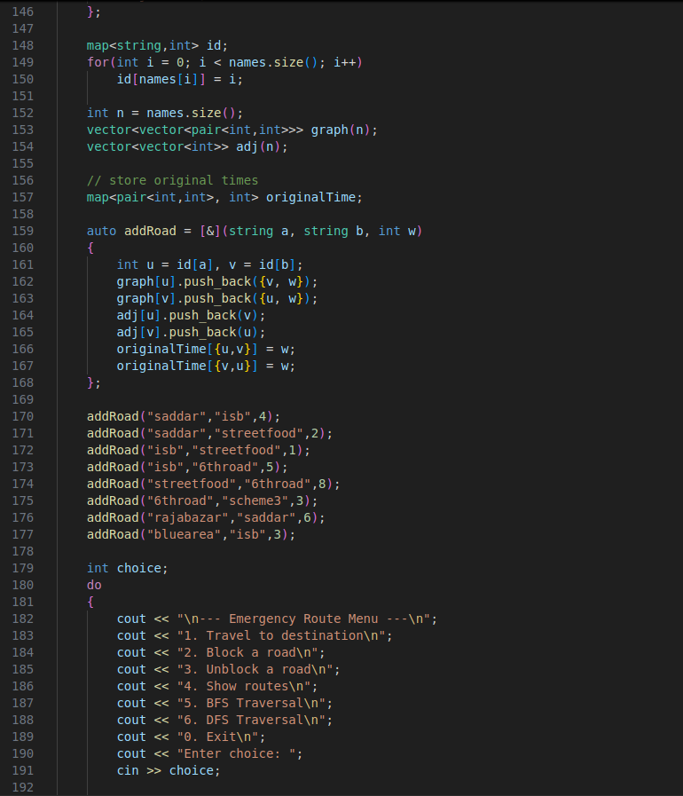
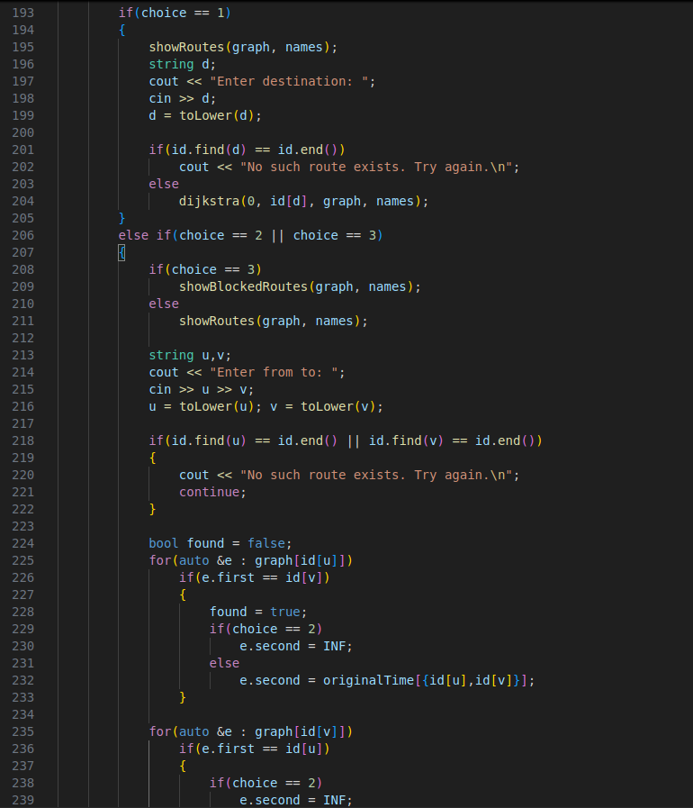
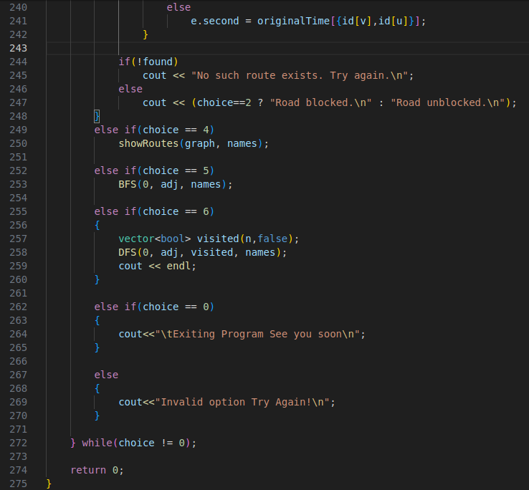
Output:
